Part 1:

Step 2:

b. 9600

d. S1>

Step 3:

1. connect
2. telnet, terminal, traceroute

telnet, terminal

Part 2:

Step 1:

1. Turn on privileged commands
2. enable, nothing because there is multiple commands that start with ‘te’
3. S1#
4. clear, clock, configure, connect, copy

Step 2:

1. Configuring from terminal, memory, or network [terminal]?
2. S1(config)#

Part 3:

Step 1:

1. \*22:40:36.591 UTC Sun Feb 28 1993
2. % Incomplete command
3. set % Incomplete command.
4. hh:mm:ss Current Time, % Incomplete command.

f. 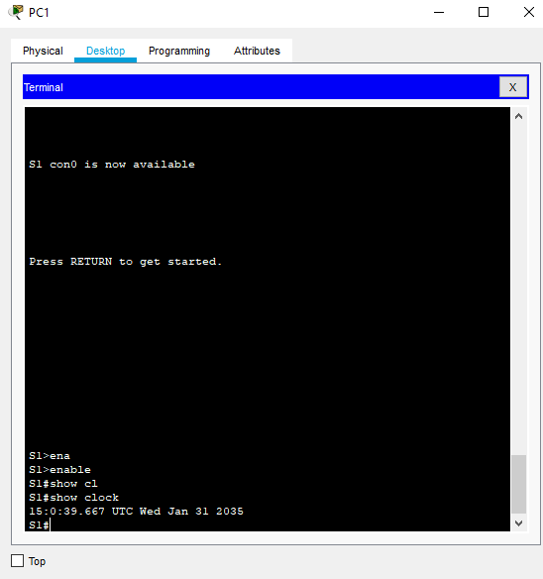

Step 2:

b. Nothing

% Incomplete command.

% Invalid input detected at '^' marker. (‘^’ pointing at the 2)

% Invalid input detected at '^' marker. (‘^’ pointing at the 3)